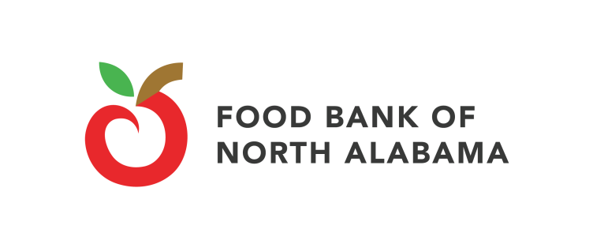

**JOB OPENING**

**I. JOB TITLE: Store Donation Coordinator**

Reports to: Operations Director

Location: Huntsville, AL

Salary Range: $42,000 to $43,000 annually, plus benefits

Type: Full-time

**II. JOB FUNCTION**

The Store Donation Coordinator will act as a goodwill ambassador to develop and maintain positive, long-term relationships with retail grocery stores in support of a food donation program for the Food Bank of North Alabama. Key responsibilities include: increasing awareness and understanding of the benefits and guidelines of the store donation program among store personnel (meat, deli, dairy, bakery, and produce managers, receivers, and store managers). Visit stores routinely, attending store meetings and store training sessions and providing “mission highlights.” Organize Food Bank tours and volunteer opportunities for store employees. Monitor and report donation progress to co-workers as well as store managers, district managers and program coordinators where applicable.

**III. BACKGROUND**

The Food Bank of North Alabama is a nonprofit, tax exempt charity affiliated with Feeding America. We procure, warehouse and distribute food to the ill, children and needy. Each year we distribute nearly 8 million pounds of food to over 100,000 people in North Alabama through a network of 240 charitable feeding programs – including food pantries, soup kitchens and children backpack programs. We also pursue proactive solutions to end hunger and poverty through initiatives aimed at supporting local farmers and improving our local food system.

**IV. DUTIES AND RESPONSIBILITIES**

* Implement a store visitation plan and accompany Food Bank drivers on routes to store donors, personally following up with store staff members from all departments.
* Foster reliable and consistent communication with retail store staff members by sharing the impact of their donations and working collaboratively with the Food Bank’s operations team to solve any issues that may arise with each targeted store.
* Cultivate long-term, positive relationship with key retail store staff members and managers through site visits and store staff meeting appearances.
* Host meetings, tours and volunteer opportunities for store personnel at the Food Bank.
* Maintain a key contact data base and become familiar with the Food Bank’s donation receipt process.
* Provide training to agency partners involved in the Retail Store Donation Program about how to best engage and cultivate store donors.
* Collaborate with other Food Bank staff to manage agencies participating in the Store Donation Program.
* Provide regular activity report on donors and donations.
* Demonstrates a pleasant, professional and helpful attitude at all times.
* Maintain fleet management program
* Assist drivers with routing.
* Engage prospective donors.
* Assist with store cause marketing campaigns and grant opportunities.
* Research and plan implementation of new data platform.
* Other duties as assigned.
* Local travel is required.

**V. QUALIFICATIONS**

Education and Experience

* Bachelor’s or associate’s degree from an accredited college or university and/or comparable experience in sales and marketing to retail customers.
* Experience in the retail grocery industry is a plus.

Skills and Abilities

* Excellent customer service and relationship building/interpersonal skills.
* Excellent communication skills (written and oral).
* Ability to self-start, work independently as well as work effectively in a team.
* Strong problem-solving skills in a team approach.
* Outgoing and communicative by nature.
* Proven ability to motivate others and foster an energizing, cooperative environment.
* Strong organizational skills with an attention to detail and accuracy.
* Proficiency using databases and Microsoft Office Professional Suite.
* Valid Alabama driver’s license and vehicle insurance.
* Passion for the Food Bank’s mission to solve hunger.
* Values align with the Food Bank’s core values: respect, accountability, collaboration, urgency, service and integrity.

**VI. ESSENTIAL PHYSICAL REQUIREMENTS**

* Ability to process information through a computer system.
* Ability to communicate with diverse constituents and staff.
* Ability to read, count and write to accurately complete all documentation.
* Ability to lift 75 pounds.
* Ability to drive motor vehicles, including a box truck if needed.
* Ability to work varied hours/days to oversee responsibilities.

**VII. FOOD SAFETY**

Commit to upholding policies, principles and best practices for food safety as well as to understand the personal responsibility to follow all safety policies and health rules, programs and procedures, to report all unsafe acts, environment or behaviors immediately and to always report safety issues, incidents or accidents immediately.

**APPLICATIONS**

To apply, please submit all of the following: **application**, **cover letter and** **resume** by close of business **March 21, 2025,** to [jobs@fbofna.org](mailto:jobs@fbofna.org).

Download applications from https://www.foodbanknorthal.org/jobs-2/.

The Food Bank of North Alabama is an equal opportunity employer and provider. EEO

For more information visit [www.foodbanknorthal.org](http://www.foodbanknorthal.org).   
This job description does not constitute a contract. Thank you for your interest!